BIT/2024/73820
Week 7
Data management and storage intergration
The chosen data management storage app is SQLite as it is user friendly and simple to use due to its CRUD operations.
User is authenticated locally via SQLite query
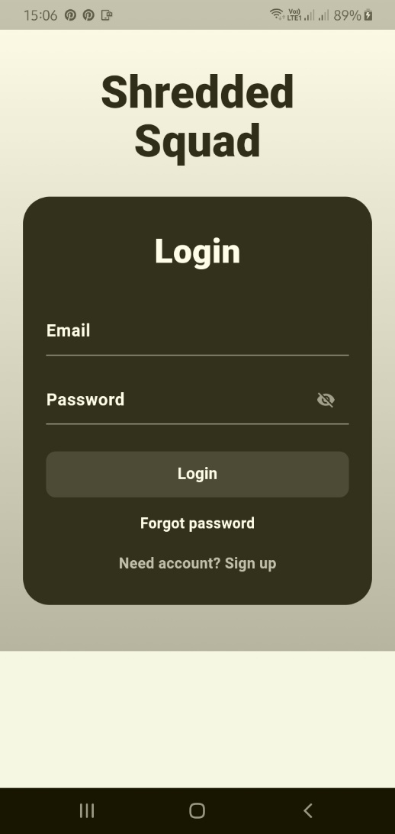

Meals are stored permanently in local database
